**Custom Loss**

**Latest Submission Grade 100%**

**1.**

Question 1

One of the ways of declaring a loss function is to import its object. Is the following code correct for using a loss object?

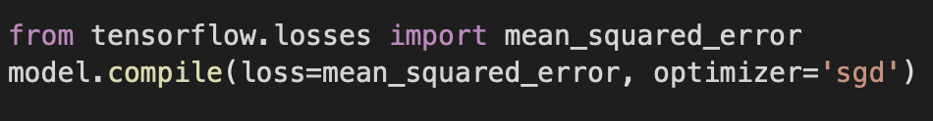

**1 / 1 point**



False



True

**Correct**

Correct! You import from tensorflow.keras.losses.

**2.**

Question 2

It is possible to add parameters to the object call when using the loss object.



**1 / 1 point**



False



True

**Correct**

Correct! Adding parameters provides flexibility for other steps such as hyperparameter tuning.

**3.**

Question 3

You learned that you can do hyperparameter tuning within custom-built loss functions by creating a wrapper function around the loss function with hyperparameters defined as its parameter. What is the purpose of creating a wrapper function around the original loss function?

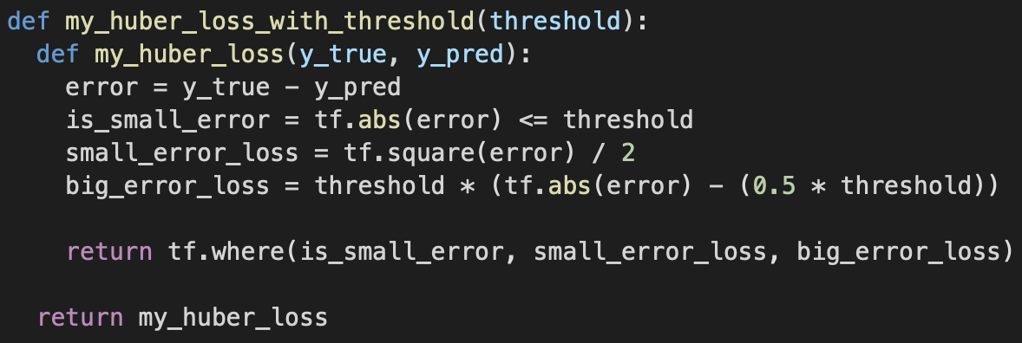

**1 / 1 point**



The loss ( model.compile(..., loss = ) ) expects a function that is only a wrapper function to the loss function itself.



That’s one way of doing it. We can also do the same by passing y_true, y_pred and threshold as parameters to the loss function itself.



The loss ( model.compile(..., loss = ) ) expects a function with two parameters, y_true and y_pred, so it is not possible to pass a 3rd parameter (threshold) to the loss function itself. This can be achieved by creating a wrapper function around the original loss function.



No particular reason, it just looks neater this way.

**Correct**

Correct!

**4.**

Question 4

One other way of implementing a custom loss function is by creating a class with two function definitions, init and call.

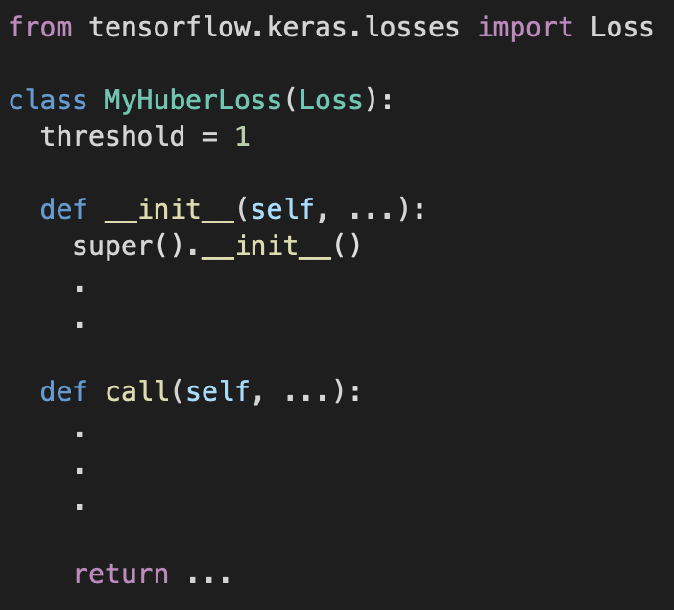

Which of the following is correct?

**1 / 1 point**



We pass y_true and y_pred to the init function, the hyperparameter (threshold) to the call function.



We pass the hyperparameter (threshold) , y_true and y_pred to the call function, and the init function returns the call function.



We pass the hyperparameter (threshold) , y_true and y_pred to the init function, and the call function returns the init function.



We pass the hyperparameter (threshold) to the init function, y_true and y_pred to the call function.

**Correct**

Correct! Threshold is passed into the inherent init function to initialize it as a class object and pass it back to the base class, and y_true and y_pred are passed into the call function when the class object, threshold, is instantiated.

**5.**

Question 5

The formula for the contrastive loss, the function that is used in the siamese network for calculating image similarity, is defined as following:

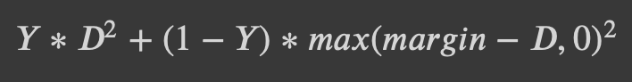

Check all that are true:

**1 / 1 point**



Margin is a constant that we use to enforce a maximum distance between the two images in order to consider them similar or different from one another.



*D*s are 1 if images are similar, 0 if they are not.



If the euclidean distance between the pair of images is low then it means the images are similar.

**Correct**

Correct!



*Y* is the tensor of details about image similarities.

**Correct**

Correct!